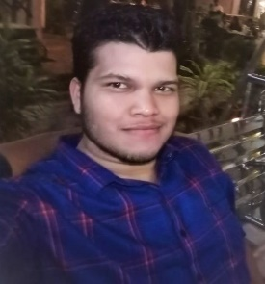RESUME

RAKESH SAMAL

MOBILE NO- 9337019956

ADDRESS- Near Dash Industries, Khalri, Angul.

Email-Id- [rsamal484@gmail.com](mailto:RSAMAL484@GMAIL.COM)

Career Objective

**Seeking an opportunity to work in a challenging environment in order to prove my skills an utilize my knowledge and intelligence for the growth of the organization.**

Educational Qualification

|  |  |  |  |
| --- | --- | --- | --- |
| CLASS | BOARD/UNIVERSITY | YEAR | PERCENTAE |
| B.COM | GOVERNMENT COLLEGE | 2019 | 62% |
| 12TH | CBSE | 2016 | 65% |
| 10TH | CBSE | 2014 | 68% |

Technical Skills

* Well versed MS Excel, MS Word, MS PowerPoint.
* Efficient in internal and basics computer knowledge.
* Completed GST Tally, MARG erp9+.

Strength

* Hard Working and Honest.
* Positive Attitude
* Team Work Skills
* Self Motivated

PERSONAL DETAILS

* Father’s Name - Kshyamanidhi Samal
* Date Of Birth - 13/09/1997
* Gender - Male
* Nationality - Indian
* Language - English, Hindi, Odiya.
* Hobbies - Reading Books and Magazines.